Email Template for Students – Survey Outreach

Hi all,
Our school has received an exciting opportunity from leading citizenship charity Young Citizens for our students to take part in their Youth Consultation Survey – please complete it in your spare time!

What is the Survey about?
Young Citizens want to know how they can help empower you to become an Active Citizen! They want to make sure your voice and communicate your ideas to powerful-policy makers – making citizenship more accessible for young people in the UK.

Win a £20 Gift Voucher!
Everyone who completes the survey will be in the running for a £20 Gift Voucher! Choose between brands like Boots, Sports Direct, H&M and more – the choice is yours! 4 winners will be randomly selected – as long as you finish the survey.

How can I take part?
If you are between 14 – 18 years old, click the link or scan the QR code below to access the survey! It should take you no more than 10 minutes. Answer 12 questions and fill out your information at the end of the survey – please make sure you fill out all sections!
https://www.surveymonkey.co.uk/r/voiceheard2023

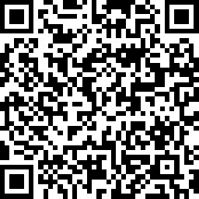

If you have any questions about the survey, please get in touch with Young Citizens at info@youngcitizens.org.
We hope you enjoy taking part in the survey!
Kind regards,
[insert your name]

